
SRM Institute of Science and Technology
College of Engineering and Technology
School of Computing
SRM Nagar, Kattankulathur – 603203, Chengalpattu District, Tamilnadu
Academic Year: 2023-24 (EVEN) BATCH-2 SET – B
Test: CLA-T2 Date: 22-03-2024
Course Code & Title: 18CSC303J & Database Management Systems Duration: 2 Periods
Year & Sem: III Year / VI Sem Max. Marks: 50
Course Articulation Matrix:
S.  No. | Course Outcome | PO1 | PO2 | PO3 | PO4 | PO5 | PO6 | PO7 | PO8 | PO9 | PO10 | PO11 | PO12 | PSO1 | PSO2 | PSO3
1 | CO1 | 3 | 2 | 2 | - | - | - | - | - | - | - | - | - | 2 | 2 | -
2 | CO2 | 3 | 2 | 2 | - | - | - | - | - | - | - | - | - | 2 | 2 | -
3 | CO3 | 3 | 3 | 3 | - | - | - | - | - | - | - | - | - | 2 | 2 | -
4 | CO4 | 3 | 3 | 3 | 2 | - | - | - | - | - | - | - | - | 2 | 2 | -
5 | CO5 | 3 | 2 | 2 | - | - | - | - | - | - | - | - | - | 2 | 2 | -

Part B (2 x 5 marks= 10)
Answer any TWO questions
21 | Write about Joins in database tables  A SQL Join is a special form of generating a meaningful data by combining multiple tables relate to each other using a “Key”. Typically, relational tables must be designed with a unique column and this column is used to create relationships with one or more other tables. When you need a result-set that includes related rows from multiple tables, you’ll need to use SQL join on this column  The various SQL join types are as follows  - SQL inner join  - Equi join  - Non-equi join (Theta join)  - SQL outer join  - SQL left join or left outer join  - SQL right join or right outer join  - SQL full join or full outer join  - SQL cross join  - SQL self join  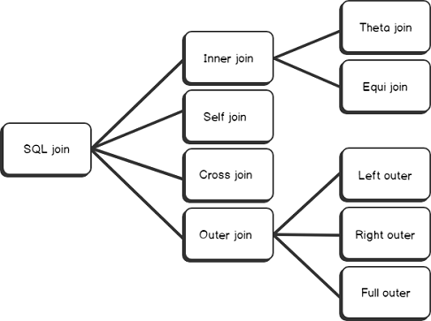 | 5 | L2 | 2 | 1 | 1.7.1
22 | Consider the following relational schema that manages the telephone bills of a mobile phone company. CUSTOMER ( SSN, Name, Surname, PhoneNum, Plan)  PRICINGPLAN ( Code, ConnectionFee, PricePerSecond )  PHONECALL ( SSN, Date, Time, CalledNum, Seconds)  BILL ( SSN, Month, Year, amount )  Suggest the company to update the customer's bill on each call. [Hint:- Trigger].  Key:  create trigger CallCharges  after insert of PHONECALL  for each row  begin  update BILL B  set Amount = Amount + ( select PP.ConnectionFee +  PP.PricePerSecond * new.Seconds  from PRICINGPLAN PP join CUSTOMER C  on C.Plan = PT.Code  where new.SSN = C.SSN )  where B.SSN = new.SSN and B.Year = new.Date.year  and B.Month = new.Date.month  end | 5 | L3 | 4 | 2 | 1.7.1
23 | Explain conditional statements in PL/SQL  Types of Conditional Statements  - if condition then statement  set serveroutput on;  DECLARE  x int:=10;  y int:=80;  BEGIN  if(y>x) then  dbms_output.put_line('Result: ' ||y|| ' is greater than ' ||x);  end if;  END;  - if condition then else statement  set serveroutput on;  DECLARE  x int;  BEGIN  x := &x;  if mod(x,2) = 0 then  dbms_output.put_line('Even Number');  else  dbms_output.put_line('Odd Number');  end if;  END;  - nested if condition then statements  set serveroutput on;  DECLARE  a int;  b int;  BEGIN  a := &a;  b := &b;  if(a>b) then  dbms_output.put_line(‘a is greater than b’);  elsif(b>a) then  dbms_output.put_line(‘b is greater than a’);  else  dbms_output.put_line(‘Both a and b are equal’);  end if;  END;  - if condition then elseif condition then else statements  set serveroutput on;  DECLARE  a int;  b int;  BEGIN  a := &a;  b := mod(a,2);  CASE b  when 0 then dbms_output.put_line('Even Number');  when 1 then dbms_output.put_line('Odd Number');  else dbms_output.put_line('User has not given any input value to check');  END CASE;  END; | 5 | L2 | 4 | 2 | 2.3.1
Part B (2 x 10 marks= 20)
Answer any TWO questions
24 | - Explain all the four SET operations with syntax for the below given tables.  TFirst  TSecond | 5 | 3 | 3 | 2 | 1.6.1
  ID | NAME
  ID | Name
  1 | Jack
  2 | Harry
  3 | Jackson
  ID | Name
  3 | Jackson
  4 | Stephan
  5 | David
- Answer: Union
Select * from Tfirst Union Select * from Tsecond;
ID | Name
1 | Jack
2 | Harry
3 | Jackson
4 | Stephan
5 | David

- Union all
Select * from Tfirst Union All Select * from Tsecond

ID | Name
1 | Jack
2 | Harry
3 | Jackson
3 | Jackson
4 | Stephan
5 | David

- Intersection
Select * from Tfirst intersect Select * from Tsecond
3 | Jackson

- Minus
Select * from Tfirst Minus Select * from Tsecond
ID | Name
1 | Jack
2 | Harry

25 | Explain the concept of query optimization in a Database Management System (DBMS). Briefly discuss two techniques used for query optimization.  Answer:  Query optimization is the process of selecting an efficient execution plan for evaluating the query. After parsing of the query, parsed query is passed to query optimizer, which generates different execution plans to evaluate parsed query and select the plan with least estimated cost.  Query optimization Techniques:  - Use indexes effectively  - Avoid SELECT * and retrieve only necessary columns  - Optimize JOIN operations  - Minimize the use of subqueries  - Avoid redundant or unnecessary data retrieval  - Utilize stored procedures  - Consider partitioning and sharding  - Normalize database tables  - Monitor query performance  - Use UNION ALL instead of UNION  - Optimize subquery performance  - Leverage cloud database-specific features | 5 | L2 | 4 | 2 | 1.7.1
26 | Imagine you are designing an extended ER model for a hospital management system. The system needs to handle information about patients, doctors, medical records, appointments, and billing. Patients can have multiple medical records, each handled by a different doctor. Doctors can have multiple appointments with different patients. Medical records contain details about diagnoses, treatments, and medications prescribed. Appointments include information about the patient, doctor, date, and time. Billing information includes invoices, payments, and outstanding balances.  Given this scenario, describe the entities, relationships, and attributes you would include in your extended ER model. Explain how you would represent the relationships between patients, doctors, medical records, appointments, and billing in the Extended ER diagram  Ans:  In an Entity-Relationship (ER) diagram, incorporate features such as specialization, generalization, and aggregation to represent more complex relationships and structures. | 10 | L3 | 2 | 2 | 2.6.5
*Program Indicators are available separately for Computer Science and Engineering in AICTE examination reforms policy.
Course Outcome (CO) and Bloom’s level (BL) Coverage in Questions

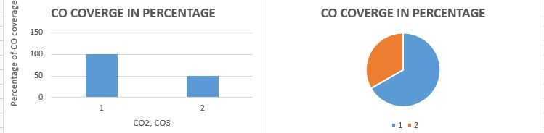

Approved by the Audit Professor/Course Coordinator

